The Lower Bound of AGV Scheduling Problem
with Alternative Pick up and Delivery Nodes

Chatpun Kaamyat, Peerayuth Charnsethikul
Operations Research and Management Science Units
Department of Industrial Engineering, Kasetsart University

Abstract

The original single/multi automated guided vehicle (AGV) scheduling problem with a specific pick up and delivery node can be formulated and solved as single/multi traveling salesman problem (TSP/MTSP). For solving TSP/MTSP, the branch and bound approach with solving the assignment sub–problem of each branching is usually used. When the original AGV problem is modified to capture the special network structure that is the network which has alternative for some node, the problem becomes the AGV scheduling problem with alternative pick up and delivery nodes. TSP/MTSP with alternative nodes will be considered for finding the solution of this corresponding problem. The purpose of this paper is to provide the mathematical model of AGV scheduling problem with alternative pick up and delivery nodes, which is TSP/MTSP with alternative nodes, and the relaxation model which is the assignment problem with alternative nodes. We will present the initial study and its assignment sub-problem. We try to create a mathematical model of assignment sub-problem with alternative nodes that can provide the lower bound of the original problem. This special assignment problem plays the important role in solving TSP/MTSP with alternative nodes as the sub problem of each branching and can provide the lower bound for the branch and bound approach. The formulated integer programming model of this extended assignment problem is verified and tested by using Excel Solver to determine the lower bound of some simulated examples.

Keywords: Assignment problem, Traveling salesman problem, Integer linear programming, and Vehicle routing problem.
- Introduction
Job scheduling and sequencing is an important part of any kind of vehicle routing design problem, including an Automated Guided Vehicle (AGV) system design. Designing an AGV system is a complex task. One of the main purposes of scheduling problem for single/multi AGV concerns about how the scheduling can provide the minimum of total traveling distance of AGV. Normally the scheduling problem have been considered or designed with the routing problem concomitantly for any kind of vehicle system management, Laporte (1997). The ordinary vehicle scheduling and routing problem as single/multi AGV scheduling problem is the problem with single specific pick up and delivery node that can be simulated by some network problem approach such as single/multi Traveling Salesman Problem (TSP/MTSP). Dantzig, Fulkerson and Johnson (1954) proposed that determining the optimal of TSP for large number of nodes requires too much time so that many papers propose the heuristic algorithm for finding the AGV scheduling and traveling path. As NP–hard nature of original TSP, the vehicle management problem with alternative pick up and delivery nodes may be considered as the class of NP–hard problem also when the problem structure fall into the TSP category, Chartrand and Oellermann (1993). According to this point, the potential problem for studying the single/multi AGV scheduling problem is extended to be more realistic problem that the original TSP problem is modified by adding the structure of alternative pick up and delivery nodes. The main purpose is to find the scheduling of AGV problem with alternative nodes. This kind of AGV problem is presented in section 2.
The original TSP/MTSP is one of the applications of network problems, it is necessary to choose a sequence of nodes to visit so as to accomplish a specified objective. TSP/MTSP is a network problem that given a network and a cost (or distance) associated with each arc, it is necessary to start from a specified originating or depot node, visit each and every other node exactly one, and return to the starting node in the least cost manner. For example, a bus that leaves the school yard must stop at various locations once to pick up students and ultimately return to the school yard in the shortest possible time. As another example, we consider the AGV system that can start from a specified originating or depot node, visit each and every other node, which has some alternative for selection to visit only one, exactly one, and return to the starting node in the least distance. The TSP/MTSP is presented in section 3. The TSP/MTSP can be solved for determining the scheduling of normal vehicle routing problem, but we have to modify the original TSP/MTSP to support the AGV problem with alternative pick up and delivery nodes.
The concept of TSP/MTSP will be applied with some generated technique of assignment problem to solve the AGV scheduling problem with alternative pick up and delivery nodes for determining the minimum traveling distance of each AGV from depot to some appropriate selected nodes and then come back to depot. This procedure based on the branch and bound with solving assignment sub problem for searching the optimal. The formulated mathematical model is presented in section 4. The assignment problem with alternative node is considered as an important part of this paper. We will describe the assignment model and the solving approach for finding the lower bound of the AGV problem with alternative pick up and delivery nodes in section 5. The ordinary assignment problem is 0–1 integer linear programming. By the unimodular property of network problem, we can solve the assignment problem as a regular linear programming without concerning of integer constrain. The result is an integer solution automatically. When the alternative nodes constraint is added to the system, the problem will lose the unimodular property. The new 0–1 integer programming model of assignment problem with alternative is created. We test implementation of the generated model by formulated the Excel Solver. Finally, the result and conclusion are presented in section 6.
- The Automated Guided Vehicle (AGV) Problem
Productivity and flexibility, which are the primary goals of today’s automation technology, can only be achieved in fully integrated manufacturing environments. A carefully designed and efficiently managed material handling system is an important part.
Tanchoco and Moodie (1987) proposed the study of AGV system. Automated guided vehicles (AGV) are among the fastest growing classes of equipment in the material handling system of industry. They are battery–powered, unmanned vehicles with programming capabilities for path selection and positioning. They are capable of responding readily to frequently changing transport patterns, and they can be integrated into fully automated intelligent control systems. These features make AGV a viable alternative to other material handling methods, especially in job shop environments where the variety of products processed results in fluctuating transport requirements. In such a dynamic and sophisticated environment, the job scheduling is one of the key factors in a successful implementation of an AGV system.
A unit load continues to circulate in the shop floor between departments until it complete. It is the transaction of unit load that generate the vehicle dispatching or job assignment and scheduling problem in an AGV system. There are so much works on vehicle dispatching directed specially to the control of AGV. Different models were developed under various constrains and cost-effective assumption. One of the AGV problem that focus on how to determine the minimum distance of AGV has been solve by many approaches such as applying the transportation problem, TSP or Postman Problem. Blair, Charnsethikul and Vasques (1987) modeled the optimum routing problem of AGV between the workstations as TSP. An algorithm for the near optimal routing of AGV in such a system is presented which seeks to organize material moves into tours with the objective of minimizing the maximum tour length.
The original AGV problem can be transformed to TSP/MTSP for solving the special situation that the jobs of AGV have the alternative nodes. The TSP/MTSP solution can be generated by many approach, but the branch and bound approach with solving assignment sub problem is considered, Ahuja, Magnanti and Orlin (1993). Suppose some part of the same example list of jobs that one AGV is used to complete all jobs is showed as following.

Job No. | Pick up Department | Delivery Department
1 | B | C
2 | A | I
3 | B | H or G or I
4 | G | C
5 | D | E
6 | D or H | F
Table 1: The example of a part of job list for one AGV

The table of TSP is consists of the distance of the AGV that move from the starting point of previous job to the starting point of next job. So the TSP distance table for the AGV problem is asymmetric distance table. Suppose the table of the previous AGV job list that is the distance from the considered job to the others in form of TSP is showed as following.

T  F | job # | #1 | #2 | #3 |  |  | #4 | #5 | #6
Job# | Alternative  (job i, alt. a) | 1.1 | 2.1 | 3.1 | 3.2 | 3.3 | 4.1 | 5.1 | 6.1 | 6.2
#1 | 1.1 | - | 3 | 2 | 2 | 2 | 5 | 4 | 2 | 4
#2 | 2.1 | 7 | - | 7 | 7 | 7 | 6 | 7 | 7 | 7
#3 | 3.1 | 2 | 3 | - | - | - | 3 | 2 | 2 | 2
#3 | 3.2 | 6 | 5 | - | - | - | 3 | 4 | 6 | 4
#3 | 3.3 | 6 | 7 | - | - | - | 5 | 6 | 6 | 6
#4 | 4.1 | 5 | 6 | 5 | 5 | 5 | - | 7 | 5 | 7
#5 | 5.1 | 2 | 3 | 2 | 2 | 2 | 3 | - | 2 | 2
#6 | 6.1 | 4 | 7 | 4 | 4 | 4 | 5 | 4 | - | -
#6 | 6.2 | 3 | 5 | 7 | 4 | 2 | 6 | 7 | - | -
Table 2: The cost matrix c_{ij} of the AGV problem with alternative
nodes in form of TSP
- TSP Mathematical Model
When we consider mathematical formulation of the routing problem, there are so many kind of mathematical model for many kind of problem, Chartrand and Oellermann (1993). For example, vehicle routing problem (VRP), the Chinese postman problem (CPP), and Traveling salesman problem (TSP) is the focused model. Lawler, Lenstra, Kan and Shmoys (1995) proposed the survey of general TSP. TSP/MTSP can be formulated as integer programming. Orman and Williams (2004) presented many formulations of the TSP as an integer programming such as the conventional formulation that is presented by Dantzig, Fulkerson and Johnson (1954) and the others sequential formulation such as Miller, Tucker and Zemilin (1960), Gavish and Graves (1978), Finke, Claus and Gunn (1983) and etc. We try to analysis the structure of mathematical model of TSP with structure of assignment sub problem. Consider the existing mathematical model as follows:
– VRP
Minimize 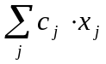
Subject to:
(SP) 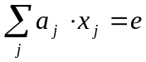
X is binary for all j
– CPP
Minimize W = 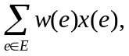
Subject to: X(e) ≥ 1 for all e ε E
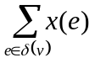 is even, for all v ε V
X(e) is the number of times the edge e is traversed in the tour.
The Miller–Tucker–Zemlin (1960) formulation of classical TSP is given as following:
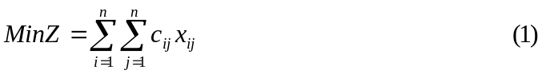
Subject to
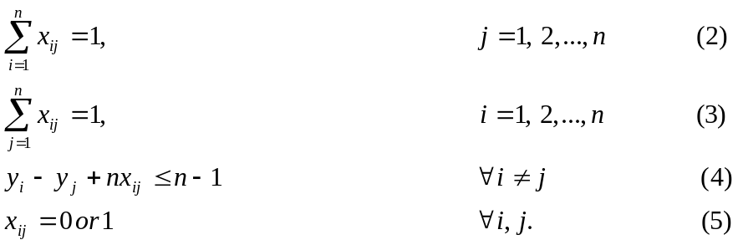
The number of cities is n, the distances are c_{ij} and the arcs in the tour are represented by the variable x_{ij}. The c_{ij} is the distance from city i to j (c_{ij} = α for i = j ). x_{ij} is 1 if the salesman travels from city i to j and 0 otherwise. The variables y_{i} are arbitrary real numbers which satisfy the constrain (4). Bellmore and Hong (1974) proposed the transformation of MTSP for m-salesman to the classical TSP by adding m–1 dummy to the original network as the artificial starting node and solved MTSP from solving TSP of the modified network. The mathematical formulation of MTSP can be formed by applying the transformation idea to the the Miller–Tucker–Zemlin formulation.
Svestka and Huckfeldt (1973) gave the multi traveling salesman (MTSP) formulation for m salesman as following.
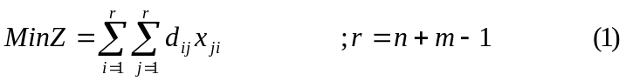
Subject to
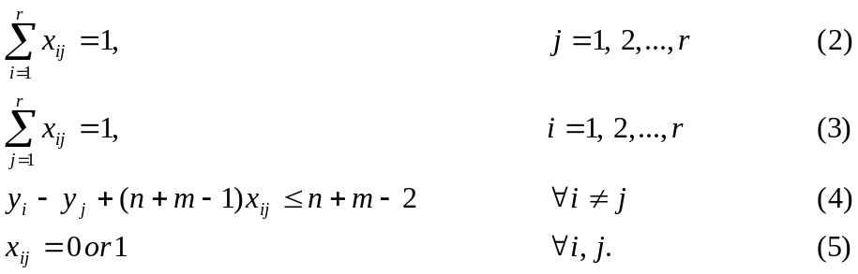
The new distances d_{ij} are defined from the original distance c_{ij} as following: Augment the matrix [c_{ij}] with m–1 new rows and columns, where each new row and column is a duplicate of the first row and column of the matrix [c_{ij}]. It is assumed that the first row and column correspond to the home city. Set all other new element of the augment matrix to infinity. All other terms have the same definition as previous model.
- Problem Formulation
From the previous mathematical math model, we do the analysis and create the model with alternative node as following when n = number of job and m = number of AGV.
Subject to
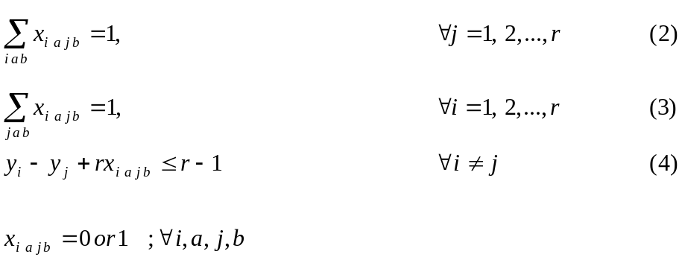
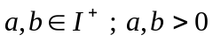
x_{iajb} = 1 ; If one AGV travel from job i with alternative a to job j with
alternative b,
- ; otherwise
d_{iajb} represent the distance from pick up node of job I with alternative a (i.a)
(Through the path to delivery node of this job + empty travel distance to
the pick up node of the next job, which is job j) to the pick up node of
job j with alternative b (j.b)
m = 1 when we consider single AGV
This mathematical model is a TSP/MTSP with alternative node that can simulate the model of single/multi AGV scheduling problem with alternative pick up and delivery nodes. When we relax the constraint (4) that is the subtour elimination constraint and consider the single AGV case, this problem looks like the assignment problem, but there are the alternative nodes for each job. This assignment problem with alternative nodes is the 0–1integer programming that is the relaxation of TSP/MTSP with alternative nodes. For solving TSP/MTSP with alternative nodes, we have to apply the branch and bound approach with solving the assignment problem with alternative nodes as a sub problem of each branching. The solution from solving this assignment problem provides the lower bound of AGV scheduling problem with alternative pick up and delivery nodes. Let consider the following assignment problem model.
- The lower bound of AGV scheduling problem with alternative nodes
The mathematical model of assignment problem with alternative nodes is presented as follows:
Subject to
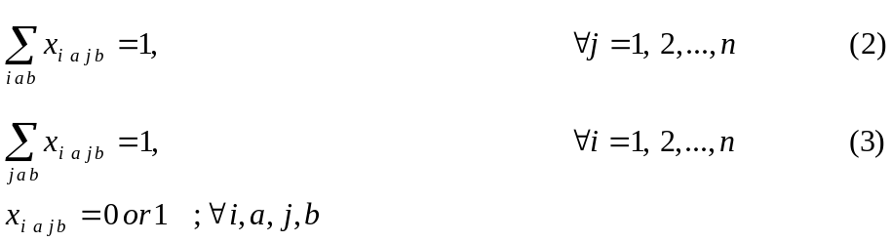
The above assignment problem with alternative nodes can be modified to be the simpler mathematical model as following.
Subject to
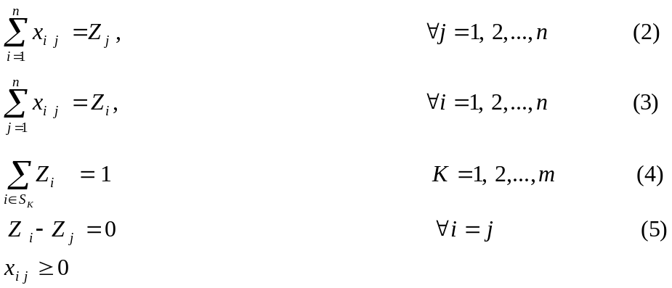
Set S_{K} is the set of any job #i that consist with all alternative of these job. For example, we can define set S_{K} of table 1 (n = 9, m = 6) that are S₁ = {1}, S₂ = {2}, S₃ = {3, 4, 5}, S₄ = {6}, S₅ = {7}, S₆ = {8, 9}.
Now we can solve the assignment problem with alternative nodes by integer linear programming (IP) for finding the lower bound of AGV scheduling problem with alternative pick up and delivery nodes. Excel Solver is used to evaluate this formulation. Let consider the example of the given network problem with alternative nodes following.
- Result of Model Evaluation
We simulate the network problem of six nodes with two alternative jobs. Suppose the given network can be express in form of matrix as follows:

T  F | job# | #1 | #2 | #3 |  |  | #4 | #5 | #6
Job# | Alternative  (job i, alt. a) | 1.1 | 2.1 | 3.1 | 3.2 | 3.3 | 4.1 | 5.1 | 6.1 | 6.2
#1 | 1.1 | - | 3 | 2 | 2 | 2 | 5 | 4 | 2 | 4
#2 | 2.1 | 7 | - | 7 | 7 | 7 | 6 | 7 | 7 | 7
#3 | 3.1 | 2 | 3 | - | - | - | 3 | 2 | 2 | 2
#3 | 3.2 | 6 | 5 | - | - | - | 3 | 4 | 6 | 4
#3 | 3.3 | 6 | 7 | - | - | - | 5 | 6 | 6 | 6
#4 | 4.1 | 5 | 6 | 5 | 5 | 5 | - | 7 | 5 | 7
#5 | 5.1 | 2 | 3 | 2 | 2 | 2 | 3 | - | 2 | 2
#6 | 6.1 | 4 | 7 | 4 | 4 | 4 | 5 | 4 | - | -
#6 | 6.2 | 3 | 5 | 7 | 4 | 2 | 6 | 7 | - | -

Table 3: The cost matrix c_{ij} of the assignment problem with alternative nodes
If we need to solve the assignment problem of this example, the key question of the above problem is “How can we select the best alternatives that can provide the minimum assignment cost?” We already known that the assignment problem can be solved efficiently by “Hungarain Method” but this method can not be applied directly to solve this special structure. We implement the mathematical model of assignment problem with alternative nodes by modeling this example network in Excel Solver. The model is a linear integer programming that the Excel Solver can provide the solution which is the lower bound of AGV scheduling problem with alternative pick up and delivery nodes. Now we can solve the assignment problem with alternative nodes as linear programming (LP) or integer programming (IP) by specific x_{ij} ≥ 0 or x_{ij} is 0 or 1. If the solutions from Solver with constraint of x_{ij} ≥ 0 are integer, not fractional number, this problem can be solved easier than using IP. If not, we have to add the binary constrain (x_{ij} is 0 or 1) to the model and solve the problem as IP.
After we implement this model by using Solver, we found that some Cost matrix gave the solutions of xij are fractional number. So we can not solve this assignment model by LP (x_{ij} ≥ 0). Now we can conclude that the sub problem of alternative selection can be solve by this model as 0–1 IP. The solution of this example by Excel Solver is shown as follows:

T  F | job# | #1 | #2 | #3 |  |  | #4 | #5 | #6
Job# | Alternative  (job i, alt. a) | 1.1 | 2.1 | 3.1 | 3.2 | 3.3 | 4.1 | 5.1 | 6.1 | 6.2
#1 | 1.1 | - | 0 | 0 | 0 | 0 | 0 | 1 | 0 | 0 | 1
#2 | 2.1 | 0 | - | 0 | 1 | 0 | 0 | 0 | 0 | 0 | 1
#3 | 3.1 | 0 | 0 | - | - | - | 0 | 0 | 0 | 0 | 1
#3 | 3.2 | 0 | 0 | - | - | - | 1 | 0 | 0 | 0 | 1
#3 | 3.3 | 0 | 0 | - | - | - | 0 | 0 | 0 | 0 | 1
#4 | 4.1 | 0 | 1 | 0 | 0 | 0 | - | 0 | 0 | 0 | 1
#5 | 5.1 | 0 | 0 | 0 | 0 | 0 | 0 | - | 1 | 0 | 1
#6 | 6.1 | 1 | 0 | 0 | 0 | 0 | 0 | 0 | - | - | 1
#6 | 6.2 | 0 | 0 | 0 | 0 | 0 | 0 | 0 | - | - | 1
 |  | 1 | 1 | 1 |  |  | 1 | 1 | 1

Table 4: The matrix x_{ij} =1of the assignment problem
From the solution, the assignment is:
1 – 5, 2 – 3.2, 3.2 – 4, 4 – 2, 5 – 6.1 and 6.1 – 1
with the solution of minimum total distance 74 unit.
We can see that this solution provide two subtour that can assign for 2 AGVs or any kind of vehicle, which stat at node 1 and node 2, because there are 2 subtours. This solution can be the lower bound of single/multiple AGV scheduling problem with alternative pick up and delivery nodes. This lower bound can be used in branch and bound approach to find the TSP that is the optimal scheduling of AGV problem. If we consider the network of the previous assignment, we can examine some structure as following.

2
3.1

Subtour: 1
3.2
4
3.3

1
6.1

Subtour: 2
6.2
5

We simulate 20 different network problems with six nodes of problem size to test the mathematical model. The results show that the model can provide the solution and satisfy all constraints of all problems. There are some solutions providing the assignment as a single tour that is the TSP solution also but most of them generate subtour. According to this point, we can apply the model to any size of problem, but the running time is not examined further than six nodes. We found that this mathematical model can provide the solution of assignment problem with alternative nodes.
- Conclusion and Extensions
In this study, the mathematical model of the AGV scheduling problem with alternative pick up and delivery nodes and the relaxation model which is assignment problem with alternative nodes are purposed. The assignment problem with alternative nodes is solved to find the lower bound of the AGV scheduling problem with alternative pick up and delivery nodes. This study is conducted because the assignment problem is a sub problem that we have to solve in all iteration of solving TSP/MTSP by branch and bound framework. This paper creates the base knowledge for studying the TSP/MTSP with alternative pick up and delivery nodes that will be applied for solving the AGV scheduling problem with alternative pick up and delivery nodes in the future.
The assignment problem with alternative node has some special structure modified from the original assignment problem and can not be solved by the traditional solving approaches for the original assignment problem. This special structure creates effect on the unimodular property of the assignment problem. The 0–1 integer linear programming of original assignment can be solve as regular linear programming with out concerning of integer constraint by unimodular property of network problem, but when the alternative constraints are added, the model will lose the property. We create the new mathematical model structure for formulating the assignment problem with alternative node by modifying the original assignment problem structure. The created model is still the 0–1 integer linear programming.
The simulated problem is generated to verify the model by using Excel Solver to model each network problem and solve the problem. The model can provide the assignment solution correctly that can be used as the lower bound tour or subtour for TSP/MTSP with alternative pick up and delivery nodes. These assignment solutions from all simulated problems satisfy all model constraints and can provide the lower bound of the AGV scheduling problem with alternative pick up and delivery nodes and the solving procedure by using branch and bound approach in the future.
References
Ahuja, R.K., T.L. Magnanti and J.B. Orlin (1993) Network Flows: Theory, Algorithms, and Applications, Prentice Hall, 1sted, pp 846.
A.J. Orman & H.P. Williams (2004) A survey of different integer programming formulations of the traveling salesman problem, Working paper by London school of economics and political science,1, No. LSEOR 04.67.
Blair, P. Charnsethikul, and A. Vasques (1987) Special issue: Automated Guided Vehicle Systems, Material Flow, 4.
Burkard, R.E. and U. Derigs. (1980) “A assignment and matching problem,” Lecture note in economic and mathematical system, 184, pp 56–68.
Chartrand, G. and O.R. Oellermann (1993) Applied and Algorithmic Graph Theory, McGraw Hill, 1sted, pp 395.
Claus, A. (1984) “A new formulation for traveling salesman problem,” SIAM J. Alg. Disc. Math. , 5, pp 21–25.
Dantzig, G.B., D.R. Fulkerson and S.M. Johnson (1954) “Solution of a large scale traveling salesman problem,” Operations Research, 2, pp 393–410.
Ford, L.R. and D.R. Fulkerson (1962) Flows in Networks, Princeton University Press, 1sted, pp 194.
J.M.A. T anchoco and C.L. Moodie (1987) Special issue: Automated Guided Vehicle Systems, Material Flow, 4.
Laporte, G. (1997) “Modeling and solving several classes of arc routing problems as Traveling salesman problems,” Computers and Operations Research, 24, pp 1057–1061.
Lawler, E.L., J.K. Lenstra, A.H.G. Rinnooy Kan and D.B. Shmoys (1995) The Traveling Salesman Problem, Wiley, Chichester.
Miller C.E., A.W. Tucker and R.A. Zemlin (1960) “Integer programming formulation of traveling salesman problems,” J. ACM, 3, pp 326–329.
Padberg M. and T.Y. Sung (1991) “An analysis comparison of different formulations of the traveling salesman problems,” Mathematical Programming, 52, pp 315–352.
S. Lin and B.W. Kernighan (1973) “An effective heuristic algorithm for the traveling salesman problems,” Operations Research, 21, pp 498–516.

